

END OF TERM 1 2024 EXAMS

GEOGRAPHY PAPER 2

SENIOR THREE

Time:2hrs 15mins

**Instructions to candidates**

* Attempt any two questions from all.

1.East Africa has experienced a lot of changes in the weather and climate patterns in the recent years. The rainfall seasons have changed and temperature increase is high. The new climate patterns have caused a lot of suffering to people in terms of floods, famine due to crop failure, death of animals due to lack of pasture, outbreak pests like locusts, frequent landslides, difficulty in transport and poverty in various areas.

The governments of East Africa and the civil society organizations are trying to help people in the affected areas by giving handouts like food, financial donation, temporary shelter, medicine among others to reduce the suffering of the communities. However, these interventions look to be short term and not long term because climate is still changing.

**Task:**

Explain the causes of climate change in the world (10mks)

What are the effects of climate to the people.(10 mks)

2. The government has discovered minerals in your area and it wants to start the extraction and establish a processing industry. However, the people who have lived in the area are against the government project because their land is a source of their livelihood in terms of agriculture, hunting and food gathering, wood products, settlement and fishing. The members of the community are mobilizing themselves to fail government efforts in all ways. The government officials have been asked to meet with the members of the community to find a way of how to sensitize them about the government project.

**Support:**

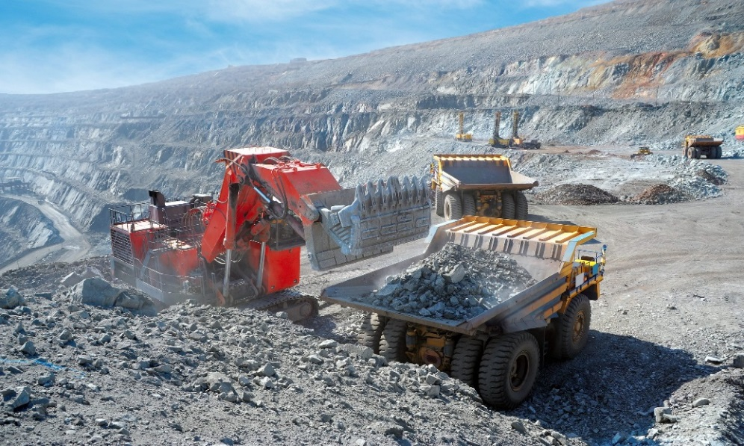

**Task:**

1. Explain the benefits of mining to the development of east Africa (10mks)
2. What are the problems facing mining in East Africa. (10mks)

3.Uganda is embraced with a variety of tourist attractions of which have attracted tourists from various parts of the world both within east Africa and out side east Africa.

**Task**

1. Discuss the factors that have favored the development of tourism industry in east Africa (10mks)
2. Explain the benefits of tourism to the development of east Africa. (10mks)
3. There are various climatic zones in the world covering various continents of the world.

**Tasks**

1. Identify any five climatic zones of the world (10mks)
2. Describe characteristics of each climatic zone mentioned in (a) above. (10mks)

END